A Multivariate Analysis of Climate Characteristics in Hong Kong's King's Park
Sun Zhen
Student ID:36446874
Tutor:Ting Chai Wen

Monash University

Email: zsun0080@student.monash.edu
Applied Session:FIT5147 Data exploration and visualisation

Abstract—This report investigates the climate characteristics of Hong Kong’s King’s Park using multivariate visualisation techniques. Daily climate observations, including global solar radiation (GSR), rainfall (RF), sunshine duration (SUN), and relative humidity (RH), were analysed to identify long-term trends, seasonal patterns, and relationships among variables.
The analysis shows that sunshine duration has a strong positive relationship with solar radiation, while rainfall and relative humidity are negatively associated with solar radiation. Seasonal variation is also evident, with summer and spring showing higher levels of solar radiation and sunshine hours, whereas winter and autumn display lower values. Correlation analysis, scatterplots, boxplots, and LOESS smoothing reveal both linear and non-linear relationships between climate variables.
The findings demonstrate that multivariate visualisation is effective for understanding complex climate interactions and identifying seasonal climate behaviour in Hong Kong. These results provide a clearer understanding of how multiple weather variables interact over time and may support future climate monitoring and environmental planning.
- INTRODUCTION
Climate analysis is important for understanding environmental conditions, weather variability, and long-term climate behaviour. In highly urbanised regions such as Hong Kong, climate variables such as solar radiation, rainfall, sunshine duration, and relative humidity can have significant impacts on daily life, energy consumption, public health, and urban planning.
King’s Park is one of Hong Kong’s major meteorological stations and provides a long-term record of climate observations. Because of its reliable and continuous data collection, it is widely used for studying local weather and climate conditions.
This report focuses on four key climate variables:
- Global Solar Radiation (GSR)
- Rainfall (RF)
- Sunshine Duration (SUN)
- Relative Humidity (RH)
The main objective of this study is to explore the relationships between these variables through multivariate visualisation techniques. Specifically, the report aims to:
- Examine long-term and monthly trends in climate variables.
- Identify seasonal differences in weather patterns.
- Investigate correlations between solar radiation, rainfall, sunshine duration, and humidity.
- Explore whether the relationship between sunshine hours and solar radiation changes across seasons.
- Demonstrate how multivariate visualisation can support climate analysis.
To achieve these objectives, a range of visualisation methods is used, including line charts, boxplots, heatmaps, scatterplots, pairplots, seasonal faceting, and LOESS smoothing curves. These techniques allow both overall trends and detailed relationships to be observed more clearly.
The report is organised as follows. Section 2 describes the dataset and variables used in the study. Section 3 explains the data cleaning and preparation process. Sections 4 to 6 present the trend analysis, seasonal patterns, and multivariate relationships. Finally, the report concludes with a discussion of the main findings and implications.
- DATA DESCRIPTION
The dataset used in this report was obtained from the Hong Kong Observatory and contains daily climate observations recorded at King’s Park meteorological station. King’s Park is located in the urban area of Kowloon and is one of the most important weather observation stations in Hong Kong.
The analysis focuses on four climate variables that are closely related to weather conditions and solar energy availability:

TABLE I
Variable | Description | Unit
GSR | Global Solar Radiation | MJ/m²
RF | Rainfall | mm
SUN | Sunshine Duration | hours
RH | Relative Humidity | %
Global Solar Radiation (GSR) measures the total amount of solar energy received at the Earth’s surface. Rainfall (RF) records the amount of precipitation observed each day. Sunshine Duration (SUN) measures the number of hours of bright sunshine, while Relative Humidity (RH) reflects the amount of moisture in the air.
The original data files were stored separately by variable and year. Therefore, the first stage of the project involved combining multiple files into a single daily dataset. After merging, the final dataset contained all four climate variables matched by date.
The dataset covers multiple years of observations, allowing both short-term seasonal variation and longer-term climate patterns to be explored. Because the data are recorded daily, the dataset contains a large number of observations, making it suitable for multivariate visualisation and correlation analysis.
Before analysis, several data preparation steps were required to ensure consistency and accuracy. These steps included converting date formats, handling missing values, standardising variable names, and merging files into a unified structure. The details of this process are described in the next section.
- Data Cleaning and Preparation
Data cleaning and preparation were necessary because the original climate records were stored in four separate CSV files and used slightly different formats. The raw data were imported from CSV files in R, with the first two rows skipped because they contained metadata rather than tabular observations. Only the first five columns of each dataset were retained and standardised as Year, Month, Day, Value, and Completeness.
Several cleaning procedures were then performed. Missing values represented by "***" or blank entries were converted to NA. The Year, Month, Day, and Value columns were converted into numeric format to ensure consistency. A Date variable was then created by combining the year, month, and day fields.
To improve reliability, only records marked as complete ("C") in the Completeness column were retained. This removed incomplete or uncertain observations from the analysis. After this process, the cleaned datasets for global solar radiation (GSR), rainfall (RF), sunshine duration (SUN), and relative humidity (RH) were exported as separate CSV files.
Several data checking procedures were also conducted to ensure the quality of the merged dataset. Duplicate records were checked using the Date field and no duplicated daily observations were retained. Variable ranges were also inspected. Relative humidity values were confirmed to remain within the valid range of 0–100%, while solar radiation, sunshine duration, and rainfall were checked to ensure that no impossible negative values were present.
The four cleaned datasets were merged using the Date field as the key. After merging, the final dataset was sorted chronologically and rechecked to ensure that all variables aligned correctly for the same day. Additional temporal variables, including year, month, and season, were created to support long-term and seasonal analysis. Seasons were defined as winter (December to February), spring (March to May), summer (June to August), and autumn (September to November).
Overall, the cleaning and checking process ensured that the final merged dataset was accurate, consistent, and suitable for multivariate climate analysis.
- Long-term Trends
To examine long-term climate behaviour, annual averages of global solar radiation (GSR) and rainfall (RF) were calculated for each year in the dataset. These annual values were then standardised to allow both variables to be compared on the same scale.
Figure 1 presents the standardised annual trends of solar radiation and rainfall. Both variables show noticeable fluctuations over time, although the overall pattern suggests a gradual increase across the study period.
Rainfall displays stronger year-to-year variability than solar radiation, with several years showing particularly high or low rainfall values. In contrast, solar radiation changes more gradually and consistently over time.
Although both variables generally increase over the long term, their short-term behaviour is not always similar. In several years, higher rainfall appears to coincide with lower solar radiation, suggesting a potential inverse relationship between these two climate variables. This pattern is reasonable because increased rainfall is often associated with cloud cover, which reduces the amount of solar radiation reaching the surface.
However, the inverse relationship is not perfectly consistent in every year. Some years show simultaneous increases or decreases in both variables, indicating that other atmospheric conditions may also influence climate patterns at King’s Park.
The overall upward trend in both rainfall and solar radiation may reflect broader climatic changes over recent decades. These long-term patterns provide a useful context for understanding the seasonal and multivariate relationships explored in later sections.
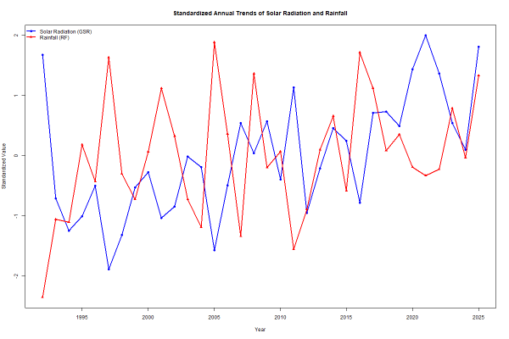

Figure 1.Standardized Annual Trends of Solar Radiation and Rainfall
- Seasonal Patterns
Seasonal analysis was conducted to understand how climate variables change throughout the year. Monthly averages of global solar radiation (GSR), rainfall (RF), sunshine duration (SUN), and relative humidity (RH) were calculated and compared.
Figure 2 shows the monthly patterns of the four climate variables. Solar radiation and sunshine duration generally increase from winter to summer, reach their highest values during the middle of the year, and then decline towards winter.
Sunshine duration remains relatively low during January and February, increases steadily from spring, and reaches its peak during summer. Solar radiation follows a similar pattern, although its highest values are observed slightly later, particularly during July and August.
Rainfall shows a very different seasonal pattern. Rainfall is relatively low during winter and early spring but increases sharply from May onwards. The highest rainfall values occur during the summer months, especially between June and August, which is consistent with Hong Kong’s wet season and typhoon period.
Relative humidity is generally high throughout the year but reaches its highest levels during late spring and summer. This suggests that the warmest months are also the most humid months.
To further examine seasonal variation in solar radiation, a monthly boxplot was created.
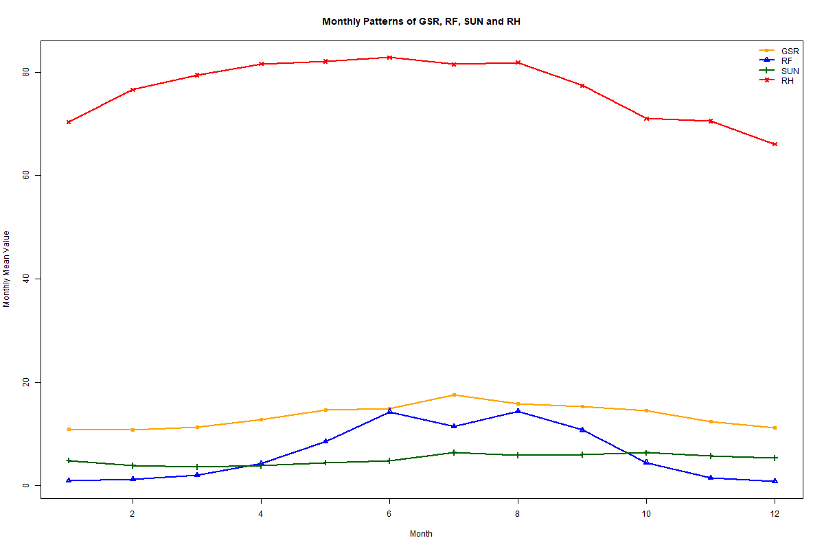

Figure 2.Monthly Patterns of GSR, RF, SUN and RH
Figure 3 shows that the distribution of solar radiation varies across months. During winter months, solar radiation values are generally lower and less variable. In contrast, the summer months show higher median values and a wider spread, indicating greater variability in solar radiation.
The boxplot also shows that some months contain several outliers, particularly during autumn. These unusual values may be related to extreme weather events, such as heavy rainfall or unusually cloudy conditions.
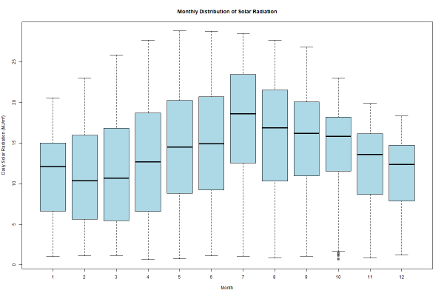

Figure 3.Monthly Distribution of Solar Radiation
Overall, the seasonal patterns suggest that climate conditions at King’s Park are strongly influenced by Hong Kong’s subtropical climate. Summer is characterised by high rainfall, high humidity, and high solar radiation, while winter is generally drier, cooler, and less sunny.
- Multivariate Relationships
To investigate how climate variables interact with each other, several multivariate visualisation methods were applied. These analyses focused mainly on the relationship between sunshine duration (SUN) and global solar radiation (GSR), while rainfall (RF) and relative humidity (RH) were incorporated as additional dimensions.
Figure 4 presents a multivariate scatterplot of sunshine duration and solar radiation. In this figure, rainfall is represented by point size and relative humidity is represented by colour intensity. A clear positive relationship can be observed between sunshine duration and solar radiation: days with longer sunshine hours generally have higher levels of solar radiation.
At low values of sunshine duration and solar radiation, the points tend to be larger and darker, indicating relatively high rainfall and high humidity. In contrast, days with high sunshine duration and high solar radiation are generally associated with smaller points and lighter colours, which suggests lower rainfall and lower humidity. This pattern supports the idea that cloudy or rainy conditions reduce incoming solar radiation and sunshine duration.
To examine whether this relationship varies across seasons, a faceted scatterplot was produced.
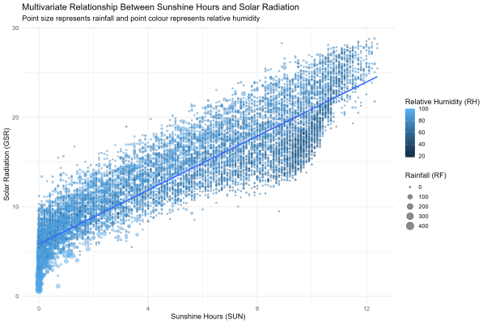

Figure 4. Multivariate Relationship Between Sunshine Hours and Solar Radiation
Figure 5 shows the relationship between sunshine duration and solar radiation separately for winter, spring, summer, and autumn. The positive relationship remains strong in all four seasons, although the spread and concentration of points differ slightly. Summer and spring display a wider range of higher sunshine and radiation values, while winter is more concentrated at lower to moderate values. This indicates that the basic relationship between SUN and GSR is stable throughout the year, but the seasonal distribution of conditions changes.
A LOESS smoothing curve was also applied to explore whether the relationship between sunshine duration and solar radiation is purely linear.
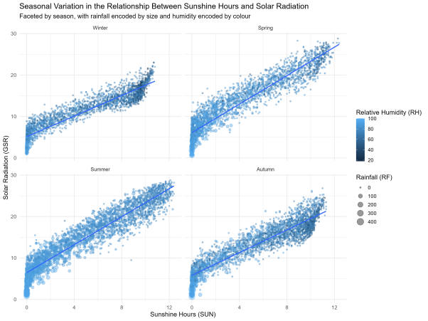

Figure 5.Seasonal Variation in the Relationship Between Sunshine Hours and Solar Radiation
Figure 6 suggests that the relationship is strongly positive overall but not perfectly linear. Solar radiation increases rapidly as sunshine duration rises from very low values, then continues to increase more gradually, and finally becomes steeper again at high sunshine levels. This indicates that the association between sunshine duration and solar radiation may contain mild non-linear behaviour.
Together, these multivariate visualisations show that sunshine duration is the strongest direct predictor of solar radiation, while rainfall and relative humidity are associated with lower-radiation conditions. These findings are also consistent with the earlier correlation analysis, which showed a strong positive correlation between GSR and SUN and negative relationships between GSR and both RF and RH.
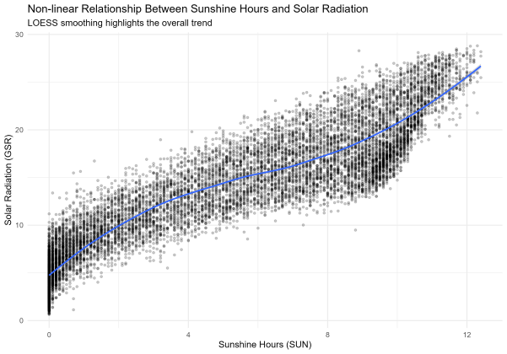

Figure 6. Non-linear Relationship Between Sunshine Hours and Solar Radiation
- Conclusion
The results of this study show that climate variables at King’s Park are closely interconnected and display both seasonal and long-term structure. Across the full study period, solar radiation and rainfall both show overall increases, although rainfall fluctuates more strongly from year to year. This indicates that long-term climate behaviour is not uniform and may be influenced by multiple environmental factors.
Seasonal analysis demonstrates that Hong Kong’s climate is characterised by clear wet and dry periods. Higher rainfall and humidity occur mainly during the warmer months, while sunshine duration and solar radiation are also elevated during much of the same period. This suggests that summer climate conditions in Hong Kong are not simply cloudy and wet, but rather involve the coexistence of strong solar input and high atmospheric moisture.
The multivariate analysis further confirms that sunshine duration is strongly associated with solar radiation, while rainfall and relative humidity tend to be linked with lower-radiation conditions. These relationships are visible both in the correlation matrix and in the scatter-based visualisations. The seasonal faceting results also suggest that although the overall SUN–GSR relationship remains stable, the distribution of climatic conditions differs by season.
One limitation of the study is that the analysis focuses only on four climate variables from a single station. Other relevant variables, such as temperature, wind speed, or cloud cover, were not included. In addition, although visualisation reveals strong associations, it does not by itself demonstrate causation.
- Reflection
This project provided valuable experience in cleaning, merging, and exploring large climate datasets using multivariate visualisation techniques. One of the most important lessons learned was that different visualisations are useful for highlighting different types of patterns. For example, line charts were effective for showing long-term trends, while scatterplots and LOESS curves were more useful for identifying relationships between variables.
The project also demonstrated the importance of data cleaning and checking before visualisation. Missing values, inconsistent formats, and incomplete records could have affected the accuracy of the analysis if they had not been handled carefully.
In hindsight, additional variables such as temperature, wind speed, or cloud cover could be included to provide a more complete picture of climate conditions. More advanced statistical methods, such as regression diagnostics or time-series decomposition, could also be applied.
- Appendix
Appendix figures may include the pairplot matrix and additional supporting charts not discussed in detail in the main report.


Appendix Figure A1. Correlation Heatmap of Climate Variables
Appendix Figure A1 shows the correlation matrix between all four climate variables. The strongest relationship is between sunshine duration and solar radiation (r = 0.91). Rainfall and relative humidity both show moderate negative relationships with solar radiation.
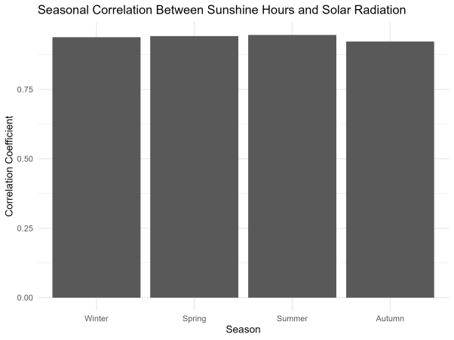

Appendix Figure A2. Seasonal Correlation Between Sunshine Hours and Solar Radiation
Appendix Figure A2 compares the correlation between sunshine duration and solar radiation across seasons. The correlation remains consistently high in all four seasons, although it is slightly weaker in autumn.
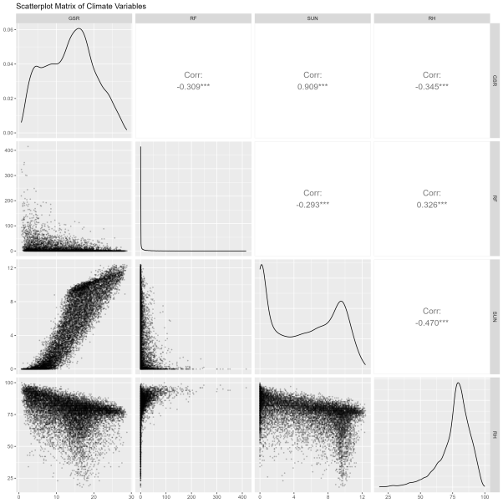

Appendix Figure A3. Scatterplot Matrix of Climate Variables
Appendix Figure A3 provides a scatterplot matrix showing pairwise relationships among all variables. The matrix confirms the strong positive relationship between sunshine duration and solar radiation, as well as the weaker negative relationships involving rainfall and humidity.
The appendix contains additional visualisations that support the main findings but are not discussed in detail in the main body of the report.
- AI Declaration
Generative AI tools were used to assist with the written expression, code refinement, and structural organisation of this report. ChatGPT was used to help improve the wording of report sections, generate explanations of visualisations, refine R code structure, and provide suggestions for report organisation. All generated content was reviewed, edited, and validated by the author before inclusion in the final report.
Reference
Hong Kong Observatory. (2025). Historical meteorological data download. Hong Kong Government Open Data Portal. https://data.weather.gov.hk/
Lu, N., Qin, J., Yang, K., & Sun, J. (2011). A simple and efficient algorithm to estimate daily global solar radiation from geostationary satellite data. Energy, 36(5), 3179–3188. https://doi.org/10.1016/j.energy.2011.03.007
R Core Team. (2025). R: A language and environment for statistical computing. R Foundation for Statistical Computing. https://www.r-project.org/
Wickham, H. (2016). ggplot2: Elegant graphics for data analysis. Springer. https://doi.org/10.1007/978-3-319-24277-4
Schloerke, B., Cook, D., Larmarange, J., Briatte, F., Marbach, M., Thoen, E., Elberg, A., & Crowley, J. (2024). GGally: Extension to ggplot2 (R package version 2.2.1). Comprehensive R Archive Network. https://CRAN.R-project.org/package=GGally
World Meteorological Organization. (2023). Climate indicators and sustainable development: Demonstrating the interconnections (WMO-No. 1290). https://library.wmo.int/idurl/4/68695

